- \Operation\Tuck In closure, Top\Tuck In closure, top
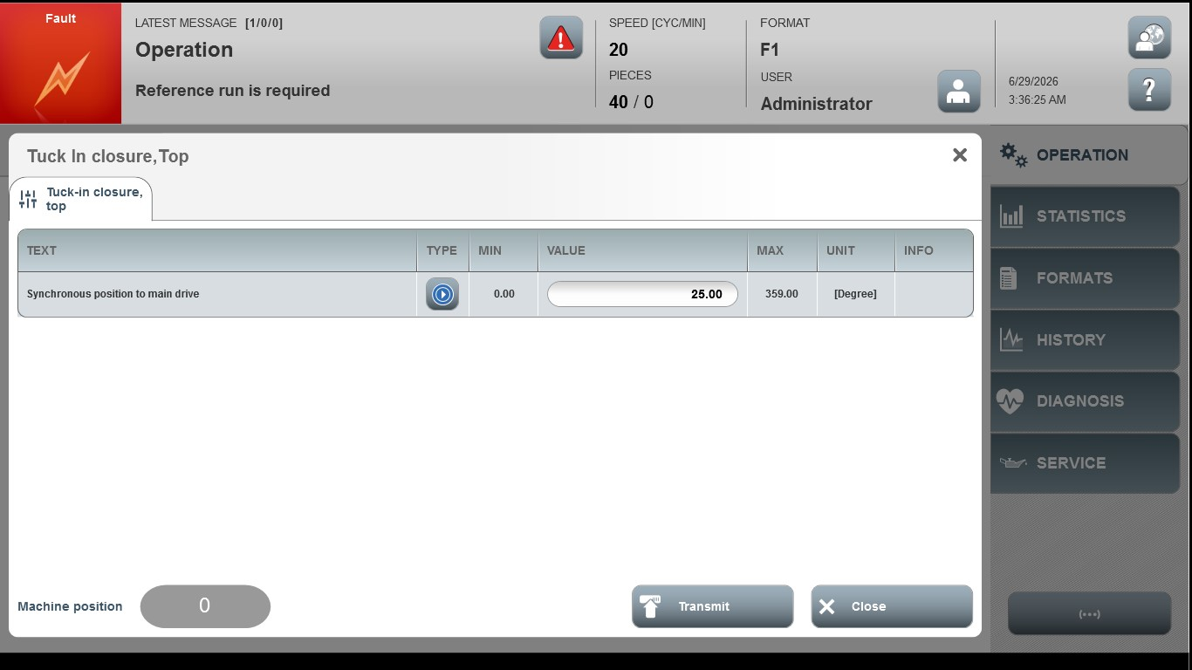
Acceptance criterion | Limits | Pass / Fail: Dev-No. | Date | Initials
Screen matches screenshot | N / A

